A-Level Geology Transition Work

Task 1 – Old Creatures, New Ideas
For a subject which studies the ancient past Geology is a surprisingly new science. From the early “gentlemen scientists” of the 19th century creating the first geological maps to major revolutions such the discovery plate tectonics and ocean ridges as recently as middle to late 20th century, the scientific world of Geology moves at quite the pace! Nowhere is this more true than in palaeontology, the study of ancient organisms. When I was a young lad dinosaurs were believed to be colossal cumbersome creatures with huge jaws but tiny brains, the notion of the frankly ‘pretty dumb’ dinosaur held for many years but with recent palaeontological finds, particularly in China there has been new light shed on these amazing beasts. It seems much more likely that dinosaurs were much smarter than we might have realised, complex herd structures, caring mothers raising their young, some dinosaurs were even nimble, agile predators darting through thick forests covered in a fine layer of brightly coloured feathers… not quite what we classically consider a dinosaur at all.

- Your task is to first track down a copy of the outstanding book Dinosaurs Rediscovered by Michael Benton (who has actually spoken to a former A-level group at BWS), it is currently available as a kindle download or in paperback on all major (online) book retailers.
https://www.amazon.co.uk/Dinosaurs-Rediscovered-Scientific-Revolution-Rewriting/dp/050005200X .

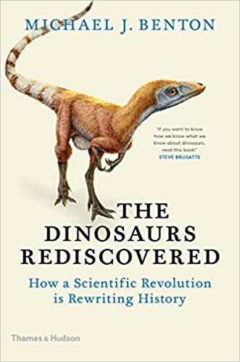

- Once you have received your copy you need to read your way through remembering all the time to think about now just what the new developments challenging our old ideas are but also how, and what, technological advancements have allowed us to get there.
- You then need to write a research piece using the information in the book as well as your own supplemental research from other sources (wider reading, documentaries, YouTube videos etc. Dr Smallwood is a big fan Planet Dinosaur the BBC documentary but I remain a dedicated follower of the classic Walking with Dinosaurs). Your research piece should aim to address the question below and should be an appropriate length, making use of diagrams, visualisations, new data etc.
- Title: When I was young Dinosaurs were scarier! What have been the most important advances in palaeontology for redefining how the Dinosaurs lived?
Task 2 – An Introduction to Geological Time
It can be tough for A-Level Geologists to really get a grip on the idea of geological time at first since it really is so vast. When we talk about events which occurred millions, and maybe even billions, of years ago we can quickly start to lose track, you might even hear a geologist saying 50 million years ago is really quite recent!

Fortunately Geologists have divided the last 4.5 billion years of Earth’s history into some discrete little packets which have some distinguishing characteristics which can help you tell them apart, for example the Permian period is dominated by arid terrains, lots of desert environments and creatures like Dimetrodon (think dinosaur like but with the “sail” on its back).

- There are lots of great website links that can explain Geological time but one of my favourites is PBS Eon YouTube channel. Start with this clip and then try the others here to build your familiarity.
- Use the BGS (British Geology Survey) as well your textbook (see task 3) to help build a geological time scale with the correct names for each of the periods. Other sites such as Geology.com might help you too. Now the hard bit, you need to try and have it memorised before you start in September! Try searching some mnemonics to help.
- Using a table like the one below try to jot down some of the distinguishing characteristics which can be used to divide one geological period from another. Think about climate, organisms (both plants and animals), rocks which might have formed, and even where the continents were at the time!
  - You will find YouTube clips useful as well as the BGS and USGS (United States Geology Survey) very useful in doing this.

Example of a section of the Geological Column you can construct showing the Cambrian.
Period | Time (Ma) | Features (e.g. climate, organisms, rocks, continents etc.)
Cambrian | 541 – 485Ma | - Time of the “Cambrian Explosion” when life suddenly appears to become much more abundant and diverse than previously seen in the geological record.  - First geological period with preserved multicellular life  - Creatures such as the bizarre Anomalacaris (an early predator with flexible tusks and a jelly-fish like mouth) and Opaninia with 5 eyes.  - Fossil sites like the Burgess Shale reveal incredible detail of fossil life.  - No life yet on land so all organisms in the sea  - Supercontinent in the process of breaking up and most of the landmass is in the Southern Hemisphere or straddling the equator.  - Very little ice, even at the poles.

- Once you’ve got your head around the timescales the next thing to try and understand is how the rocks formed during each period of time are distributed across the British Isles, i.e. where they can found. The British Geological Survey have produced a resource called Make A Map (https://www.bgs.ac.uk/discoveringGeology/geologyOfBritain/makeamap/map.html) which allows you to see how rocks of different ages are spread across the UK, you can use this tool to help identify which age rocks are exposed beneath our homes, as well as in certain parts of the UK.
  - Identify the age of rocks beneath your home
  - Suggest some patterns and trends that you can see, think for example where the majority of the extrusive igneous rock (solidified lava) is and why that might be.

Task 3 – Getting Equipment
Before you start your A-level there is some equipment you’ll need for lessons and we can use this period to ensure you have everything ready.
- Aside from the stationary basics you will also require a 30cm ruler, a protractor, a plotting compass, highlighters and a few coloured pencils too.
- A good scientific calculator like the ones you will use for Maths (if you aren’t doing Maths then at least a Casio fx 85GT or similar is needed).
- A text book will be your guide at home, the best course text book is “OCR Geology for A Level and AS” written by Davies and Mugglestone. You will require a textbook for the course and we will make use of it for homework’s so it's a great tool to have ahead of time.

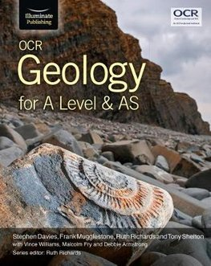

Extension Tasks and Other Ideas
Wider Reading: Exploring a New Subject
Some of you will have the opportunity and motivation for some additional reading so I have attached a list of recommended reading which can be accessed through online shops such as Amazon. My personal favourite is Trilobite! By Richard Fortey.

In addition to the reading there are absolutely tonnes of excellent programmes and Podcasts on BBC iPlayer, BBC Sounds and YouTube of which I have also featured a small selection below.

Geology Reading List
- An Ocean of Air: Walker
- Taking Flight: Shipman
- Life: A Natural History of the First 4 Billion Years: Fortey
- Trilobite!: Fortey
- A Short History of Nearly Everything: Bryson
- When Life Nearly Died: Benton
- Snowball Earth: Walker

Watch & Listen
- BBC Inside Science Podcast with Adam Rutherford
- Infinite Monkey Cage – Not strictly geology every episode but some are and there’s hundreds of back catalogue episodes.
- Planet Earth I and II
- Frozen Planet
- Inside Natures Giants
- Earth (Attenborough).
- How to Grow a Planet.
- Supersize Earth.
- The Fifteen Billion Pound Railway

MOOC – Massively Open Online Courses
You might wish to do a FutureLearn MOOC - https://www.futurelearn.com/. MOOC stands for Massive Open Online Course and is co-ordinated by Futurelearn. There are literally thousands of courses, some are as short as an hour and others longer. You can do these courses whether they are currently live or archived. They have videos, questions, quizzes and if they are currently live you can engage in the online discussion forums. You don’t need to pay for these courses (unless you want a certificate which you don’t need) and you don’t need to do the whole of any course. If you start a course and it gets too hard or you are no longer finding it interesting then you don’t need to pursue it. A few that have caught my eye include;
Life Beyond Earth: Atmospheric Chemistry: https://www.futurelearn.com/courses/atmospheric-chemistry-planets-and-life-beyond-earth
All About Moons: https://www.futurelearn.com/courses/moons

